**Question 1:**

Part a:

1. Use python code from Assignment 1 to simulate the orbit of the satellite in ECI frame.
2. Transform the ECI frame to ECEF frame.
3. From the ECEF frame, get the latitude, longitude and altitude of the satellite.
4. Do a 3D plot of the satellite in ECI and ECEF frame.
5. Produce a ground plot of the orbit (see below):

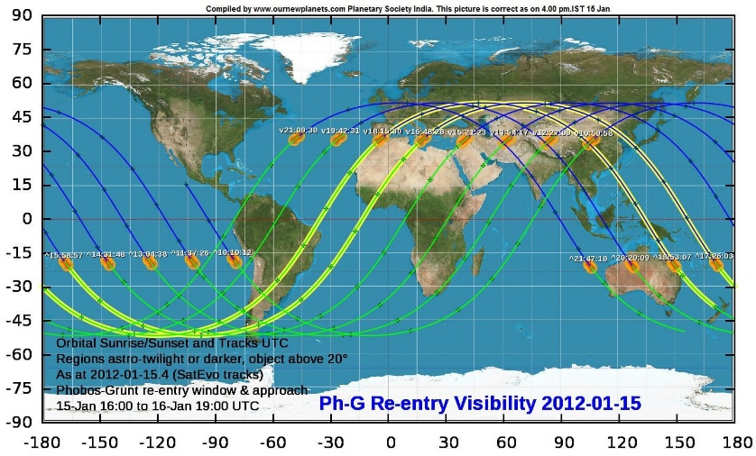

Part b:

1. Find the purpose and mission of the XMM-Newton satellite.
2. Find out how the variables relate to the satellite’s mission.

Part c:

1. Simulate the orbit but with the J2 perturbation.
2. Either modify the existing functions or make a new set of functions to model this.
3. Produce 3D plot of the satellite.
4. Include a ground trace plot of the satellite with the J2 perturbation, and show this effect over time.

Note: for q2 and q3,

* At the moment, you don’t need to include the J2 perturbation
* Start orbital transfer simulation from the epoch time in the TLE

**Question 2:**

Part a:

1. Design optimal sequence of orbital manoeuvres for a spacecraft in circular equatorial orbit to satellite orbit.
2. Decide whether the optimal sequence be time efficient, energy efficient, or compare both.
3. Simulate the orbital transfer and a revolution.

Part b:

1. Plot path and velocity of satellite over time, starting from the orbital transfer to one revolution of the final orbit.

Part c:

1. Describe the approach, methodology and rationale how the transfer trajectory was designed.
2. List assumptions made and other relevant information to execute the transfer.

**Question 3:**

Part a:

1. Design an optimal sequence of orbital manoeuvres to reach the orbit of the Comet C/2023E1 (i.e. get into its elliptical orbit, not in the orbit of the comet).
2. Simulate orbital transfer and 1 revolution.

Part b:

1. Plot path and velocity of satellite over time, starting from the orbital transfer to one revolution of the final orbit.

Part c:

1. Describe the approach, methodology and rationale how the transfer trajectory was designed.
2. List assumptions made and other relevant information to execute the transfer.